**CARRICULUM VITAE**

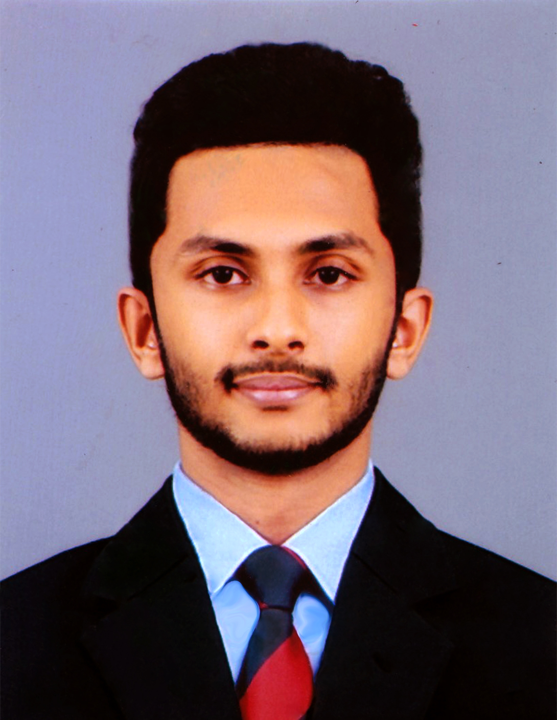

**Mr. Jayakodi J. K. B. M**

**NO. 201/ 1, Wendesiwaththa Road, Alawathugoda**

**077 – 3834946/ 081 – 2302577**

[**banuka.jayakodi1995@gmail.com**](mailto:banuka.jayakodi1995@gmail.com)

**CAREER OBJECTIVE**

Primitively, as my first step to the industry I would prefer on gaining more practical knowledge where I can apply my ongoing academic competencies, skills and strengths to uplift the company operations in a more serious way. In order to that, I am seeking a challenging and growth oriented position where my interpersonal skills can be best utilized. Rather, this will help me to identify and ensure a better path in the business world that will help me to achieve rewards. As a solution, the built in confidence will thereby allow me to take more challenging projects in the area of management while performing managerial roles and skills in a challenging way.

**PERSONAL STATEMENT**

I define myself as a well-organized, open minded and a self-disciplined person in the environment I operate and exist. Exquisitely, I possess adequate skills to coordinate the people to crave and achieve the objectives in a timely manner. Thus, appropriate levels of skills and strengths such as proper communication, interpersonal skills and leadership skills are adopted, so as to create the environment to be more favourable to myself. Hence, smart strategies can be built in and incorporated to go ahead with the ongoing task while accepting the risks associated. Accordingly, I develop a proper mission for a desired vision which can be built upon in an inspirational manner while attaining the values required persuading the necessary surroundings.

**PERSONAL INFORMATION**

* Full Name : Jayakodi Kankanamalage Banuka Madhushanka Jayakodi
* Date of Birth : 01/ 01/ 1995
* Gender : Male
* Nationality : Sri Lankan
* Religion : Buddhist
* Education : Kingswood College, Kandy (2000 – 2013)
* NIC NO. : 950010630v
* Civil Status : Single

|  |  |  |  |
| --- | --- | --- | --- |
| **Institute** | **Course** | **Status** | **Year** |
| University College of Dublin, Ireland | Bachelor of Science in Business Management (Special) | Reading | 2013 - 2017 |
| National Institute of Business Management | Higher Diploma in Business Management | Reading | 2014 - 2015 |
| National Institute of Business Management | Advanced Diploma in Business Management | Completed | 2013 - 2014 |

**ACADEMIC COMPETENCIES**

**RESEARCH AND CONFERENCE PROCEEDINGS**

* Undertaken a research regarding on the greenhouse farming and its effectiveness towards Sri Lanka.
* Developed a business plan for a newly started business under the topic of project appraisal.
* Developed a marketing plan to introduce and promote a new product (Mono Pod) to the market.

**IT AND LANGUAGE QUALIFICATIONS**

|  |  |  |  |
| --- | --- | --- | --- |
| **Institute** | **Course** | **Status** | **Year** |
| National Institute of Business Management | Advanced Certificate in English Language | Merit | 2013 - 2014 |
| ICBT Kandy Campus | Diploma in English | Completed | 2011 |
| Royal English School | English Language Improvement Programme | Completed | 2007 |

**EDUCATIONAL QUALIFICATIONS**

* General Certification of Education Advanced Level (2013 – Commerce) – Kingswood College Kandy. (Index NO. 8999333)

|  |  |
| --- | --- |
| General English | B |
| Business Studies | C |
| Economics | S |
| Accounting | S |

* General Certification of Education Ordinary Level (2010) – Kingswood College Kandy.

(Index NO. 63274752)

|  |  |
| --- | --- |
| Buddhism | A |
| English | A |
| History | A |
| Citizenship Education | A |
| Mathematics | B |
| Sinhala Language and Literature | B |
| Science | C |
| Art | C |
| Agriculture and Food Technology | C |

**EXTRAMURAL ENGAGEMENTS AND ACCOLADES**

* **UNIVERSITY LEVEL – National Institute of Business Management**
* Secretary of the event organizing committee in organizing the NIBM – Kandy “SOORYA MANGALYA” 2015 New Year Festival.
* Secretary of the event organizing committee in organizing the “VOTE FOR LIFE” Annual Blood Donation and Eye Donation Campaign 2014.
* Batch coordinator of the HDBM 14.2 batch of NIBM – Kandy Regional Centre.
* **SCHOOL LEVEL – Kingswood College, Kandy**
* President of the Kingswood Commerce Society. (2012 – 2013)
* Organized the “RENASCENTIA `13” – Annual Commerce Day as the President of the Kingswood Commerce Society.
* President of the Kingswood Banking Society (SEYLAN BANK/ PEOPLES BANK). (2012 – 2013)
* Committee member of the Old Kingswoodian Commerce Society, currently coordinating the 2013 commerce batch.
* Represent the School Swimming Team. `B` Squad (2006 – 2010)
* Organizer of the Kingswood College Astronomical Society.
* Committee member of the Kingswood College Computer Society.
* Committee member of the Kingswood College Media Unit.
* Committee member of the Kingswood College New Inventors Club.
* Committee member of the Kingswood College English Literature and Drama Association.
* Active member of the Kingswood College Youth Explorer`s Club.
* Member of Kingswood College Interact Club.
* Member of Kingswood College Drug Prevention Society.
* **OTHER**
* Senior prefect of the Sri Visuddharama Sunday School.
* President of the Sri Visuddharama Sunday School Society.

**KEY SKILLS, STRENGTHS AND COMPETENCIES**

* Strengthened skills in doing presentations
* Ability of communicating the right bit of data to the proper place in a right fashion
* Favourable leadership skills to coordinate the people that I work with
* Withhold a decent level of computer knowledge (MS Office Package, Data Recovery, etc.)
* Capability of coordinating the work properly with the available data
* Control the stress by means of smart working, self-motivation and taking further risks
* Ability of being a team player while managing different perceptions
* Handled practical assignments such as; appraising a Project for a Listed Company, Crafting Strategies for a Listed Company, etc. and a Comprehensive Research Analysis group wise.

**NON – RELATED REFEREES**

Mr. E. W. M. Lalith Ekanayaka,

High Court Judge,

High Court,

Nuwaraeliya.

077 - 2659942

Ms. Subashini Weerakotuwa

Lecturer/Consultant,

National Institute of Business Management, Kandy Regional Centre.

077 - 9352571

I do hereby certify that the information supplied above is true and correct to the best of my knowledge.

16/ 09/ 2015 J. K. B. M. Jayakodi

**Date Signature**